**Relatório de Verificação**

Análise Estática de Código

Nome:André Luiz Bernardes de Oliveira

Turma: 5 sem de banco de dados

Data: 10/03/2025

**Projeto - Python Hacks**

1. Detalhamento dos Passos de Execução da Análise

19:53:55.255 INFO Project key: br.edu.fatec:Python-hacks-sample

19:53:55.256 INFO Base dir: /home/aoliveira/Documentos/FATEC/LAB5/atividade_2/PythonHacks

19:53:55.256 INFO Working dir: /home/aoliveira/Documentos/FATEC/LAB5/atividade_2/PythonHacks/.scannerwork

19:53:55.270 INFO Load project settings for component key: 'br.edu.fatec:Python-hacks-sample'

19:53:55.321 INFO Load quality profiles

19:53:55.386 INFO Load quality profiles (done) | time=65ms

19:53:55.432 INFO Load active rules

19:53:55.728 INFO Load active rules (done) | time=296ms

19:53:55.741 INFO Load analysis cache

19:53:55.750 INFO Load analysis cache (404) | time=10ms

19:53:55.839 INFO Preprocessing files...

19:53:56.144 WARN File '/home/aoliveira/Documentos/FATEC/LAB5/atividade_2/PythonHacks/AWS_Enrich_Your_Transformed_Data/yellow_tripdata_2020-04.csv' is bigger than 20MB and as consequence is removed from the analysis scope.

19:53:56.150 WARN File '/home/aoliveira/Documentos/FATEC/LAB5/atividade_2/PythonHacks/AWS_Glue_ETL_For_Complex_DataTransformation/yellow_tripdata_2020-04.csv' is bigger than 20MB and as consequence is removed from the analysis scope.

19:53:56.194 WARN File '/home/aoliveira/Documentos/FATEC/LAB5/atividade_2/PythonHacks/GCP_Video_Intelligence_API/JaneGoodall.mp4' is bigger than 20MB and as consequence is removed from the analysis scope.

19:53:56.194 WARN File '/home/aoliveira/Documentos/FATEC/LAB5/atividade_2/PythonHacks/GCP_Video_Transcribe_API/JaneGoodall.mp4' is bigger than 20MB and as consequence is removed from the analysis scope.

19:53:56.219 INFO 8 languages detected in 854 preprocessed files

19:53:56.219 INFO 0 files ignored because of scm ignore settings

19:53:56.222 INFO Loading plugins for detected languages

19:53:56.223 INFO Load/download plugins

19:53:56.232 INFO Load/download plugins (done) | time=10ms

19:53:56.415 INFO Load project repositories

19:53:56.430 INFO Load project repositories (done) | time=15ms

19:53:56.458 INFO Indexing files...

19:53:56.459 INFO Project configuration:

19:53:56.571 INFO 854 files indexed

19:53:56.572 INFO Quality profile for docker: Sonar way

19:53:56.573 INFO Quality profile for go: Sonar way

19:53:56.574 INFO Quality profile for ipynb: Sonar way

19:53:56.574 INFO Quality profile for json: Sonar way

19:53:56.575 INFO Quality profile for py: Sonar way

19:53:56.575 INFO Quality profile for terraform: Sonar way

19:53:56.575 INFO Quality profile for web: Sonar way

19:53:56.576 INFO Quality profile for yaml: Sonar way

19:53:56.576 INFO ------------- Run sensors on module Python Hacks

19:53:56.659 INFO Load metrics repository

19:53:56.688 INFO Load metrics repository (done) | time=30ms

19:53:57.338 INFO Sensor Python Sensor [python]

19:53:57.341 WARN Your code is analyzed as compatible with all Python 3 versions by default. You can get a more precise analysis by setting the exact Python version in your configuration via the parameter "sonar.python.version"

19:53:57.364 INFO Starting global symbols computation

19:53:57.368 INFO 226 source files to be analyzed

19:54:00.609 INFO 226/226 source files have been analyzed

19:54:00.678 INFO Starting rules execution

19:54:00.678 INFO 226 source files to be analyzed

19:54:05.034 ERROR Unable to parse file: ChatGPT/TestBoto3.py

19:54:05.035 ERROR Parse error at line 1 column 9:

--> resource "azurerm_storage_account" "my_storage_account" {

2: name = "mystorageaccount"

3: resource_group_name = azurerm_resource_group.my_resource_group.name

4: location = azurerm_resource_group.my_resource_group.location

5: account_tier = "Standard"

6: account_replication_type = "LRS"

7: }

8:

9: resource "azurerm_virtual_network_peering"

19:54:05.150 ERROR Unable to parse file: AWS_Oracle_RDS_Connect_Cloud9/TestCopilot.py

19:54:05.150 ERROR Parse error at line 21 column 25:

17: b = b, a+b

18: print()

19:

20: def test_fib():

--> assert fib(10) == 0,1,1,2,3,5,8

22: assert fib(100) == 0,1,1,2,3,5,8

19:54:05.465 ERROR Unable to parse file: AWS_Glue_Using_Spark/test.py

19:54:05.466 ERROR Parse error at line 23 column 0:

1: ''''

2: There are multiple zip files in s3

3: 1. Download all the zip files

4: 2. Loop through all the zip files and extract the zip files

5: 3. Find a particular file e.g test.txt from the list of files

6: 4. From that file read line by line

7: 5. Read the content of the file and extract values of specific key

8: 6. Store the value in an array of objects

9: 7. Save the json object file

10:

11: LoginId - 124556, org - abc , ip - 12.42.56.78, loginAttempt - 20, status - failed

12: LoginId - 124556, org - abc , ip - 12.42.56.78, loginAttempt - 20, status - failed

13: '''

14: import boto

15:

16: s3_client = boto.client("S3")

17:

18: s3_client.downloadAll("C:/temp/")

19:

20: for eachzip in "C:/temp/":

21:

22:

--> store = []

24: for eachfolder in "C:/temp/unzip/":

25: for file in eachfolder:

26: if file.name() == "test.txt":

27:

19:54:05.862 INFO 226/226 source files have been analyzed

19:54:05.862 INFO The Python analyzer was able to leverage cached data from previous analyses for 0 out of 226 files. These files were not parsed.

19:54:05.863 INFO Sensor Python Sensor [python] (done) | time=8525ms

19:54:05.863 INFO Sensor IPython Notebooks Sensor [python]

19:54:05.900 INFO Starting global symbols computation

19:54:05.901 INFO 5 source files to be analyzed

19:54:05.901 INFO 5/5 source files have been analyzed

19:54:05.901 INFO Starting rules execution

19:54:05.901 INFO 5 source files to be analyzed

19:54:06.077 INFO 5/5 source files have been analyzed

19:54:06.078 INFO The Python analyzer was able to leverage cached data from previous analyses for 0 out of 5 files. These files were not parsed.

19:54:06.078 INFO Sensor IPython Notebooks Sensor [python] (done) | time=215ms

19:54:06.078 INFO Sensor Cobertura Sensor for Python coverage [python]

19:54:06.109 INFO Sensor Cobertura Sensor for Python coverage [python] (done) | time=31ms

19:54:06.109 INFO Sensor PythonXUnitSensor [python]

19:54:06.135 INFO Sensor PythonXUnitSensor [python] (done) | time=26ms

19:54:06.135 INFO Sensor HTML [web]

19:54:06.193 INFO Sensor HTML [web] (done) | time=58ms

19:54:06.193 INFO Sensor JaCoCo XML Report Importer [jacoco]

19:54:06.194 INFO 'sonar.coverage.jacoco.xmlReportPaths' is not defined. Using default locations: target/site/jacoco/jacoco.xml,target/site/jacoco-it/jacoco.xml,build/reports/jacoco/test/jacocoTestReport.xml

19:54:06.194 INFO No report imported, no coverage information will be imported by JaCoCo XML Report Importer

19:54:06.194 INFO Sensor JaCoCo XML Report Importer [jacoco] (done) | time=2ms

19:54:06.195 INFO Sensor Code Quality and Security for Go [go]

19:54:06.196 INFO 14 source files to be analyzed

19:54:06.395 INFO 14/14 source files have been analyzed

19:54:06.396 INFO Sensor Code Quality and Security for Go [go] (done) | time=201ms

19:54:06.396 INFO Sensor IaC Terraform Sensor [iac]

19:54:06.459 INFO 82 source files to be analyzed

19:54:06.780 INFO 82/82 source files have been analyzed

19:54:06.780 INFO Sensor IaC Terraform Sensor [iac] (done) | time=385ms

19:54:06.780 INFO Sensor IaC CloudFormation Sensor [iac]

19:54:07.111 INFO 4 source files to be analyzed

19:54:07.221 INFO 4/4 source files have been analyzed

19:54:07.221 INFO Sensor IaC CloudFormation Sensor [iac] (done) | time=440ms

19:54:07.221 INFO Sensor IaC Kubernetes Sensor [iac]

19:54:07.286 INFO 81 source files to be parsed

19:54:07.425 ERROR Failed to evaluate Helm file HCP_Valut_EKS/devwebapp.yaml: Failed to resolve Helm project directory

19:54:07.462 INFO 81/81 source files have been parsed

19:54:07.463 INFO 81 source files to be analyzed

19:54:07.529 INFO 81/81 source files have been analyzed

19:54:07.529 INFO 81 source files to be checked

19:54:07.630 INFO 81/81 source files have been checked

19:54:07.631 INFO Sensor IaC Kubernetes Sensor [iac] (done) | time=410ms

19:54:07.631 INFO Sensor IaC AzureResourceManager Sensor [iac]

19:54:07.679 INFO 8 source files to be analyzed

19:54:07.865 INFO 8/8 source files have been analyzed

19:54:07.866 INFO Sensor IaC AzureResourceManager Sensor [iac] (done) | time=235ms

19:54:07.866 INFO Sensor Java Config Sensor [iac]

19:54:07.887 INFO 0 source files to be analyzed

19:54:07.888 INFO 0/0 source files have been analyzed

19:54:07.888 INFO Sensor Java Config Sensor [iac] (done) | time=22ms

19:54:07.888 INFO Sensor JavaScript inside YAML analysis [javascript]

19:54:07.989 INFO No input files found for analysis

19:54:07.989 INFO Hit the cache for 0 out of 0

19:54:07.990 INFO Miss the cache for 0 out of 0

19:54:07.991 INFO Sensor JavaScript inside YAML analysis [javascript] (done) | time=103ms

19:54:07.992 INFO Sensor JavaScript inside HTML analysis [javascript]

19:54:08.215 INFO Detected os: Linux arch: amd64 alpine: false. Platform: LINUX_X64

19:54:08.216 INFO Deploy location /home/aoliveira/.sonar/js/node-runtime, tagetRuntime: /home/aoliveira/.sonar/js/node-runtime/node, version: /home/aoliveira/.sonar/js/node-runtime/version.txt

19:54:08.228 INFO Using embedded Node.js runtime.

19:54:08.229 INFO Using Node.js executable: '/home/aoliveira/.sonar/js/node-runtime/node'.

19:54:09.480 INFO Memory configuration: OS (15229 MB), Node.js (2096 MB).

19:54:09.541 INFO 5 source files to be analyzed

19:54:10.764 INFO 5/5 source files have been analyzed

19:54:10.764 INFO Hit the cache for 0 out of 5

19:54:10.765 INFO Miss the cache for 5 out of 5: ANALYSIS_MODE_INELIGIBLE [5/5]

19:54:10.765 INFO Sensor JavaScript inside HTML analysis [javascript] (done) | time=2774ms

19:54:10.765 INFO Sensor CSS Rules [javascript]

19:54:10.770 INFO 5 source files to be analyzed

19:54:10.844 INFO 5/5 source files have been analyzed

19:54:10.845 INFO Hit the cache for 0 out of 0

19:54:10.845 INFO Miss the cache for 0 out of 0

19:54:10.845 INFO Sensor CSS Rules [javascript] (done) | time=80ms

19:54:10.845 INFO Sensor IaC Docker Sensor [iac]

19:54:10.877 INFO 7 source files to be analyzed

19:54:10.923 INFO 7/7 source files have been analyzed

19:54:10.924 INFO Sensor IaC Docker Sensor [iac] (done) | time=79ms

19:54:10.924 INFO Sensor TextAndSecretsSensor [text]

19:54:10.924 INFO Available processors: 12

19:54:10.924 INFO Using 12 threads for analysis.

19:54:11.163 INFO The property "sonar.tests" is not set. To improve the analysis accuracy, we categorize a file as a test file if any of the following is true:

* The filename starts with "test"

* The filename contains "test." or "tests."

* Any directory in the file path is named: "doc", "docs", "test" or "tests"

* Any directory in the file path has a name ending in "test" or "tests"

19:54:11.174 INFO Using git CLI to retrieve untracked files

19:54:11.190 INFO Analyzing language associated files and files included via "sonar.text.inclusions" that are tracked by git

19:54:11.297 INFO 552 source files to be analyzed

19:54:13.536 INFO 552/552 source files have been analyzed

19:54:13.537 INFO Sensor TextAndSecretsSensor [text] (done) | time=2613ms

19:54:13.539 INFO ------------- Run sensors on project

19:54:13.616 INFO Sensor Zero Coverage Sensor

19:54:13.642 INFO Sensor Zero Coverage Sensor (done) | time=26ms

19:54:13.644 INFO SCM Publisher SCM provider for this project is: git

19:54:13.645 INFO SCM Publisher 420 source files to be analyzed

19:54:14.103 INFO SCM Publisher 420/420 source files have been analyzed (done) | time=457ms

19:54:14.126 INFO CPD Executor 46 files had no CPD blocks

19:54:14.127 INFO CPD Executor Calculating CPD for 196 files

19:54:14.192 INFO CPD Executor CPD calculation finished (done) | time=66ms

19:54:14.197 INFO SCM revision ID 'f112e5ecaf992904bb0937d92cdca1e835e15569'

19:54:14.438 INFO Analysis report generated in 203ms, dir size=2.6 MB

19:54:15.242 INFO Analysis report compressed in 803ms, zip size=1.6 MB

19:54:15.522 INFO Analysis report uploaded in 280ms

19:54:15.524 INFO ANALYSIS SUCCESSFUL, you can find the results at: http://localhost:9000/dashboard?id=br.edu.fatec%3APython-hacks-sample

19:54:15.524 INFO Note that you will be able to access the updated dashboard once the server has processed the submitted analysis report

19:54:15.524 INFO More about the report processing at http://localhost:9000/api/ce/task?id=7a57a008-7e96-42fb-83fe-3cdf6ee9ab5c

19:54:15.693 INFO Analysis total time: 20.643 s

19:54:15.695 INFO SonarScanner Engine completed successfully

19:54:16.024 INFO EXECUTION SUCCESS

19:54:16.026 INFO Total time: 23.278s

1. Visão Sumarizada (Overall)

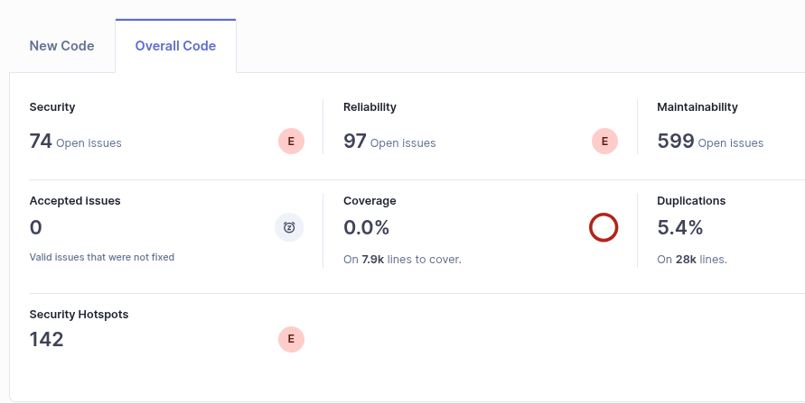

1. Visão Sumarizada (New Code Lines)

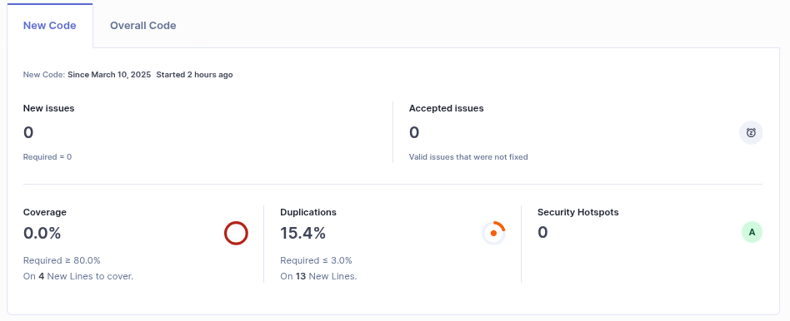

1. Quadro Quantitativo Detalhado – V0

Nr. Security Hotspots:

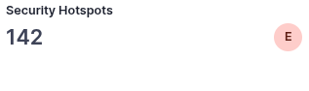

Nr. Code Smells

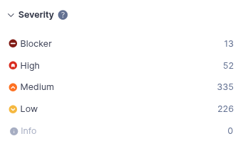

% de Cobertura de Código:

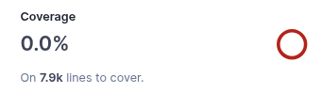

% de Duplicidade de Linhas de Código:

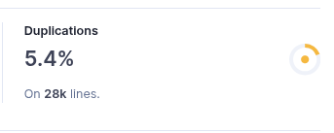

Qtde de Blocos Duplicados:



1. Top 10 – Code Smells

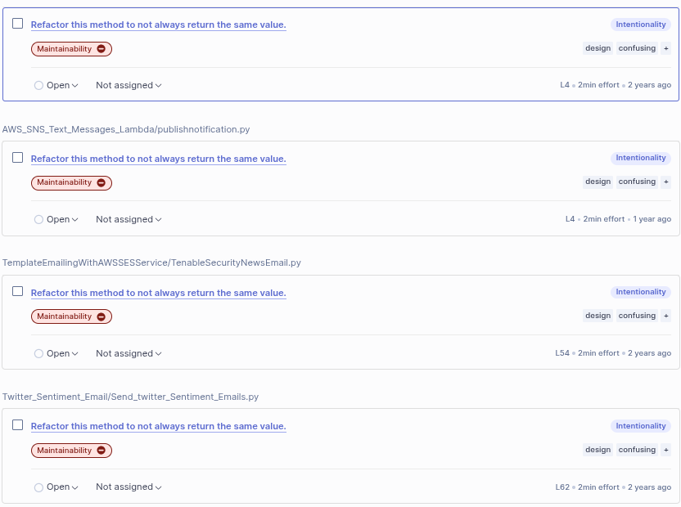

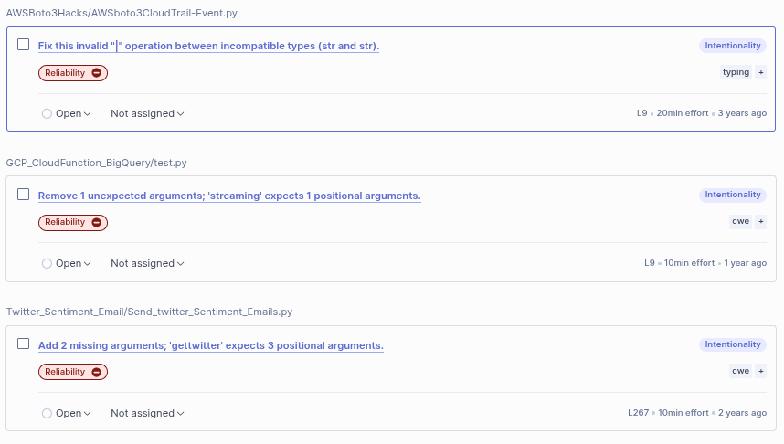

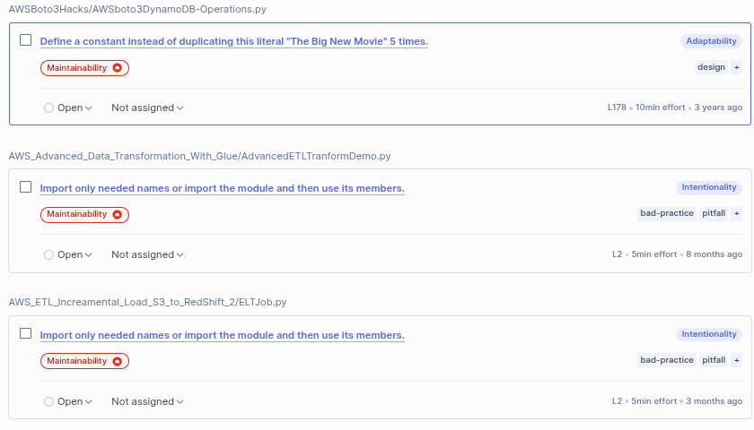

1. Estratégia de Redução de *Issues* Identificadas

Estabelecer uma estratégia gradativa que não deve ocupar mais de 20% de esforço do TimeBox de uma Sprint de 3 semanas, para atender o Quality Gate abaixo:

* Nr. Security Hotspots igual a 0
* Nr. Code Smells blocker e critical igual a 0, major <= 5, minor <=15
* % de Duplicidade de Linhas de Código igual a 0
* % de Cobertura de Código >= 80%

Acredito que o ideal seria começar pelas duplicações  
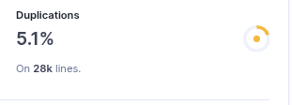  
Posteriormente, diminuir os code smells do blocker:  
  
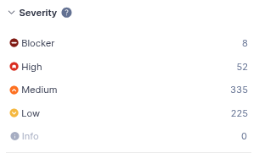

1. Quadro Quantitativo Detalhado – Após Correções

Nr. Security Hotspots:



Nr. Code Smells

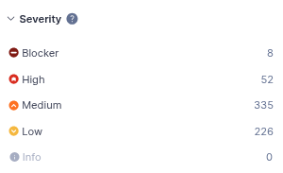

% de Cobertura de Código:



% de Duplicidade de Linhas de Código:



Qtde de Blocos Duplicados:



1. Quadro Quantitativo Detalhado – Após Remoção do Bloco de Duplicidade

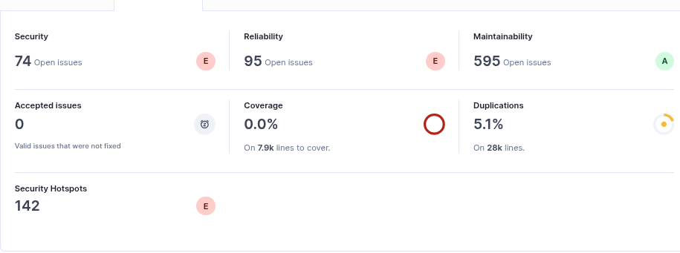

ETAPA 2:

Após correções de alguns hostspot:

